74th Starch Convention
April 18th– 20th 2023 in Detmold (Germany)

Company
Address
Phone |  | Telefax
E-Mail

The reservation of an exhibition stand of |  | 10 m² |  | 15 m² |  | 20 m² | is required.

If possible stand nr. is requested (according to the position plan).

Stand equipment (please fill in as required):
 | yes | no
Conference table + chairs
Power current (till 8 kW)

The value of the exhibition objects is approx.: €.

The exhibition terms will be accepted.

Date
Signature and Stamp
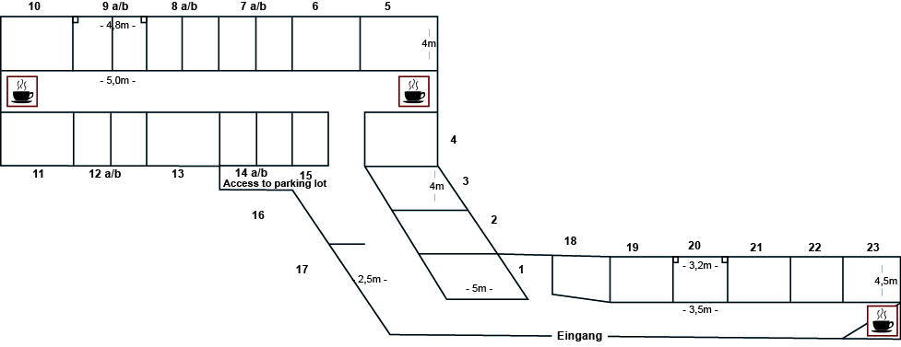
Entrance
Size of Stands:
Stands 1 – 6, 10, 11, 13: 20 m²
Stands 7 a/b, 8 a/b, 9a/b,
12 a/b, 14 a/b, 16 - 18: 10 m²
Stand 15: 12 m²
Stands 19 - 22: 15 m²
Stands 23: 10 m²

